Connor Missett
- What is the difference between a Robot Project and a Virtual Instrument?

A
features an enhanced interface that allows you to configure and
test your robot without a program, as well organize multiple program files in one place.

A
contains a single Front Panel and Block Diagram, and can be used
to create a single program and interface.

- For this question, refer to the two pictures below:
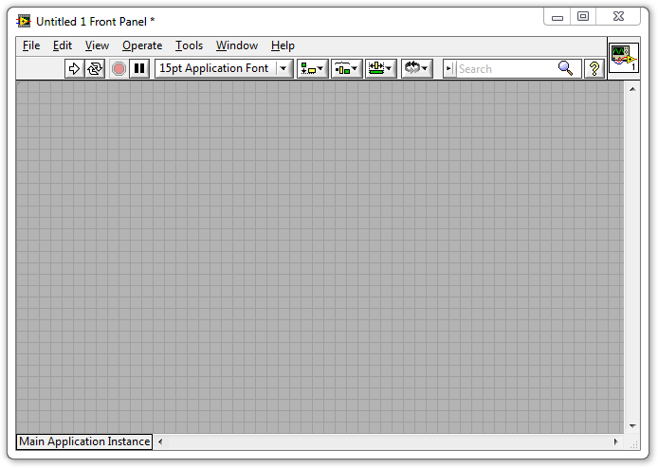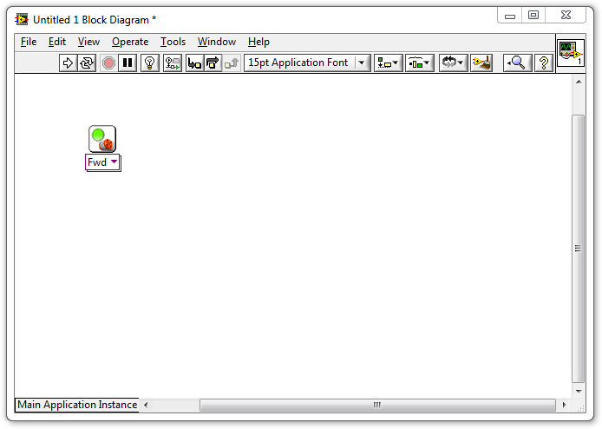
  - What is the window on the left with the grey background called?

The Block Diagram
The Main Menu
The Program Field
The Front Panel

  - What is the window on the right with the white background called?

The Block Diagram
The Main Menu
The Program Field
The Front Panel

  - Which window do you drag VIs into, to give the robot movement commands?

The Front Panel
The Program Field
The Block Diagram
The Code Schematic (not shown above)

3. What is this called?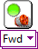

A Movement VI
A Motor Control VI
A Forward VI
The Block Diagram
4. If you want to add a Motor VI to your program...
  - Where can you find one?

In the Tools Palette
In the Functions Palette
Type the word "Motor" and press enter
In bar on the left hand side of the screen

  - How do you add it to your program?

Double-click the Motor VI in the Functions Palette
Drag the Motor VI to the Front Panel
Drag the Motor VI to the Block Diagram

5
5. How do you open the Functions Palette?

Right-click an empty area of the Block Diagram
Select Functions Palette from the View menu
Both of the above
None of the above
5
6. What command does this block give the robot?

Forward a message to the robot
Turn the motors on in the foward direction
Wait for 1 second
Stop the motors

7. What command does this block give the robot?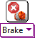

Make the robot fall apart
Turn the motors on in the foward direction
Wait for 1 second
Stop the motors
8

8. What does the pink wire indicate in this program?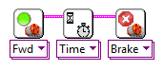

The blocks were dropped too close together
LabVIEW is currently running the commands
The commands will take place in order they are connected from left to right
This is the Primary Command Sequence for the robot
9.
- The two blocks shown below were dropped far apart and did not auto-wire. How do you connect them?

Click their top corners and use the wiring tool to connect them
Drag them closer together until the auto-wire appears
Right-click the first block and select "Wire to Nearest"
You can't wire them together if you miss the first time
10.
- Which button in the picture below that Runs the program.

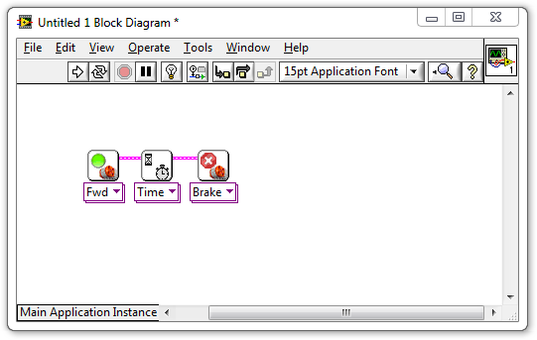
- What is a Constant (also called a Constant Modifier)?

A command that tells the robot to hold its position
Any command given to the robot that does not change its heading
Another name for a Variable Block
A "thing" representing a specific value, which can be wired into Blocks
12
- How do you set a motor to run for 5 seconds instead of 1?

Click the Motor Block and change the Duration setting to 5
Wire a Constant with a "5" in it into a Motor Block's "Time" port
Create a Constant with a "5" in it and drag it on top of the Motor Block
Drop a 5 Second Motor Block on the Block Diagram instead

- Where would you check to see what settings are available on a block and what they do?

Context Help window
Block Diagram
Front Panel
Main Menu

14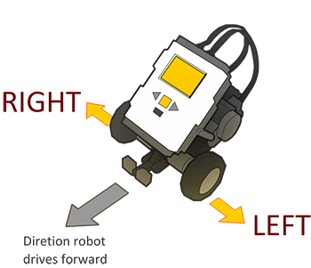
What ports are the robot's motors attached to on the default REM model?

Left Motor=A, Right Motor=B
Left Motor=B, Right Motor=C
Left Motor=C, Right Motor=B
Wheel Motors=C, Arm Motor=B

- Why are Rotations generally better than Time?

The robot's clock is inaccurate
The wheels spin more freely
Rotations always go the same distance regardless of speed or battery level
You cannot set the number of seconds the robot waits

- 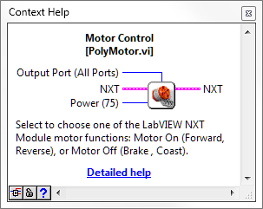
According to this picture from the Context Help menu, which of the following things can NOT be chosen on a Motor Block?

How long to keep the motors running
Which motor ports to give the command on
How much power to give the motors
All of the above can be set on the Motor Block

- Based on the same picture from the Context Help menu in question 4, what is the default value for the Power setting on the Motor Block?

75
100
All Ports
No default

18. How do you make a program that can run on the NXT without needing to be hooked up to the main computer?

Select "Target to NXT" from the File menu
Select "Send to NXT" from the Tools Menu
Choose "Run on NXT" from the NXT's LCD screen interface
LabVIEW programs cannot be run that way

- Once you have deployed the program onto the NXT, how do you run it?

On the NXT: Program Files > Run
On the NXT: My Files > Software File > (Name of .VI file) > Run
On the PC/Mac: File > Run Deployed Program
On the NXT: grey button labeled "Run Deployed"
- A robot turns when...

Its wheels move in different direction of at different speeds
You use a Motor Block set to Turn
You move the Steering slider to the left or right of center
Its wheels move together at the same speed

- If the robot's left motor goes forward while its right motor goes in reverse, how will the robot's body move?

Turn to the left
Turn to the right
Move straight ahead
Make an outward spiral

- To make the robot turn...

Change "Fwd" to "Turn" on the Motor Block
Move the steering slider to the left or right
Make an outward spiral
Give its wheels different movement commands

- If you don't specify a motor, what does the Motor Block default to?

Motor/Port A
Motor/Port B
Motor/Port C
All motors/ports

- To specify which motors a Motor Block controls, you:

Attach a Constant modifier to the Output Ports node
Change "Fwd" to the name of the motor you want
Use a "Motor A Block" instead
Select the Motor Block and type the letter of motor you want (A, B, or C)

- How do you remove a wire?

Drag the blocks apart until the wire breaks
Click on the wire and press delete
Use the scissors tool to cut the wire
Hold down the mouse button and scratch it out

What does the Sequence Structure do?

Let the program choose between multiple "frames" of code to run
Let the program repeat "frames" of code more than once
Let you hide code that you don't want to run
Allow "phases" of code to run in sequence even if individual phases involve parallelism
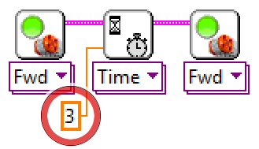
27. What is the value of this Constant circled in red above?

0
3
4
No value
28
- How is the circled Constant being interpreted by the program?

As a command to wait
As number of port
As a number of rotations
As number of seconds

- Why is it being interpreted this way?

Because it is providing its value to the Wait Block
Because it is providing its value to the "Seconds" terminal on the Wait Block
All constants are interpreted the same way
Because the value is an integer

- What does the Light Sensor detect?

Length of darkness
Intensity of red light
Robot's weight
Robot's speed

- Which would produce a HIGHER light sensor reading with a light sensor pointed at it: a dark surface or a light surface?

The light surface
The dark surface
Both the same
No reliable pattern
31.
How do you view the numeric values coming from the sensor?

Attach a digital lead to the robot
Use the View Mode on the NXT screen
Click on the Sensor Block in LabVIEW
Look closely at the back of the sensor

32. What Block tells the robot to wait for a Light Sensor reading lower than a certain cutoff threshold?

Wait Block set to Wait for Light > Darkness
Sensor Block set to Light Sensor > Darkness
Wait Block set to Wait for Light > Darker
Wait Block set to Wait for Light > Lightness

- How do you calculate a suitable Light Sensor threshold value?

Use the value from the Light surface
Use the value from the Dark surface
Use the Find Threshold Block in LabVIEW
Halfway between Light and Dark values

- How do you specify the cutoff value for determining "Dark" from "Light"?

With a Light Sensor Modifier attached to the Threshold wiring node on the Motor Stop Block
Activating View Mode automatically stores the correct value
With a Constant Modifier attached to the "Darkness" wiring node on the Wait Block
By clicking the Wait Block and typing in the value
35. What does the Sound Sensor measure?

Sound wavelength (pitch)
Sound intensity (volume)
Sound frequency (pitch)
Distance to the nearest object

36. How do you specify the cutoff value for determining "Loud" from "Quiet"?

With a Constant Modifier attached to the "Loudness" wiring node on the Wait Block
Activating View Mode automatically stores the correct value
With a Sound Sensor Modifier attached to the Threshold wiring node on the Motor Stop Block
By clicking the Wait Block and typing in the value

- Describe this program, block by block.
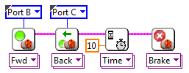

Move forward on Port B, move reverse on Port C, wait for 10 seconds, stop
Move reverse on Port B, move forward on Port C, wait for 10 seconds, stop
Move forward on Port C, move reverse on Port B, wait for 10 seconds, stop
Move forward on Port B, move reverse on Port C, wait for 10 milliseconds, stop Port A

- What will the program do to the robot?

Move reverse for 10 seconds
Move forward for 10 seconds
Swing turn for 10 seconds
Point turn for 10 seconds

39. Describe this program, by sequence.
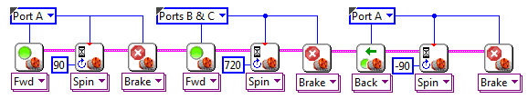

Closes claws, move forward for 2 rotations, then opens claw
Opens claws, move forward for 2 rotations, then closes claw
Opens claws, move backwards for 2 rotations, then closes claw
Opens claws, move forward for 2 degrees rotation, then closes claw

- What does it mean for two strands of code to run "in parallel"?

They are placed side-by-side on the diagram
They both START running at the same time
They both START AND STOP running together
They take turns running blocks

- These two strands of code run in parallel because
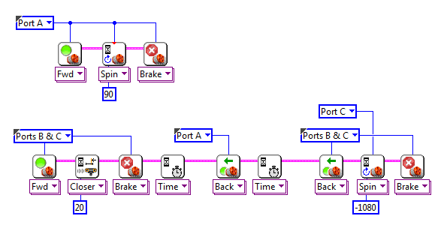

They both contain Motor Blocks
They are placed side-by-side on the diagram
Both are independent strands with no wire leading into them

- When this first strand of code finishes, the second strand:

Is unaffected because the two are independent
Stops immediately
Starts running twice as fast
Skips ahead to the last block in its strand
- What does the Sequence Structure do?

Let the program choose between multiple "frames" of code to run
Let the program repeat "frames" of code more than once
Let you hide code that you don't want to run
Allow "phases" of code to run in sequence even if individual phases involve parallelism

